Dear Parents and Carers,

Here is an overview of tasks I would like children to complete at home over the next two weeks. We are committed to making sure that your child is still learning as much as possible and endeavour to do our best to keep this happening. I would be grateful if you could email me 2 pieces of their work/ activities per day. This could just be a simple photograph of them completing a task. If there is anything that they or you need, please do not hesitate to contact me. sbroad@allsaints-trysull.staffs.sch.uk. Thank you for your support.

Warmest regards, Miss Broad.

Summer Term 2
Week 1 – Exploring our Feelings

This week some of the children will be returning to school after a long time at home. With that in mind, this week’s work is designed to explore children’s feelings;

Text of the week:
‘The Colour Monster’ by Anna Llenas

Nursery Challenges for Specific Areas of Learning

 | Maths | Phonics
Monday | Choose an episode of Numberblocks | Choose a Phonics Play Phase 1 game.
Tuesday | Sing your favourite number song | Go on a listening walk – talk about the sounds you can hear.
Wednesday | Feed Teddy some cakes and practise counting | Choose a Phonics Play Phase 1 game
Thursday | Help Peter Rabbit count objects in the vegetable patch | Can you change your voice to sound angry, happy, sad, excited or scared?
Friday | Colour these Monsters by number! | Choose a Phonics Play Phase 1 game

Reception tasks for Specific Areas of Learning

 | Maths | Phonics
Monday | Matching numbers to 20 | Daily Youtube lesson
Tuesday | Ordering numbers 11-20 | Daily Youtube lesson
Wednesday | What comes next? Ordering game. | Daily Youtube lesson
Thursday | One more than game | Daily Youtube lesson
Friday | Estimating 0-10 | Daily Youtube lesson

In addition to this, choose 1 of these literacy activities a day (both Nursery and Reception):

- Listen to our story of the week.
- Colour in your monster with how you are feeling today (see additional documents). Reception extension: Can you write about a time when you have felt that way?
- Test your knowledge of the story and colour in each feelings jar using the correct colour from the story (see additional documents)
- Write about a time when you felt happy.
- Keep practising name writing, Nursery!
- Choose a new colour for a different feeling that wasn’t mentioned in the story.

Tasks for Prime Areas of Learning. Please complete 1 of any of these a day.
Year Group: EYFS (Nursery and Reception)

PSED
- Discuss the story together and talk about times when you have felt that emotion as well as when your child has felt that way

Communication and Language
- Play this emotions board game

Physical Development
- Practise scissor skills by making different expressive faces
- It is very important for children’s development to stay active!
- Complete one of these a day:
* Go Noodle workouts on Youtube
*Cosmic Kids Yoga workouts on Youtube
*PE with Joe Wicks on Youtube at 9am every week day
*Disney 10 minute shake up activities
- Handwriting practise – please focus on correct letter formation. Handwriting worksheets are available on Twinkl.
- Nursery specific: pencil control sheets (Twinkl) to help with fine motor development and holding a pencil with the correct grip.

Understanding the World
- Make feelings lava lamps

Expressive Arts and Design
- I have created each pupil a login for ‘Yumu’ on the Charanga website which is the package we use to teach music. I have assigned them a package of work if they would like to do some music! If you would like your login and details on how to access the work, please email me.
- Explore mixing colours by mixing ‘feelings’ together (e.g. sad and happy = green)
Additional learning resources parents may wish to engage with
In addition to the resources listed in the first document sent out, I have found some more useful websites/resources you may wish to use. All of these are free of charge.

Hungry Little Minds – This contains lots of nice activity ideas. Ideas range from birth, so there’s something for little brothers and sisters too!

Tiny Happy People – This has lots of information and activities for developing communication skills from birth through to 5 years.

Additional Documents

Name _______________________________

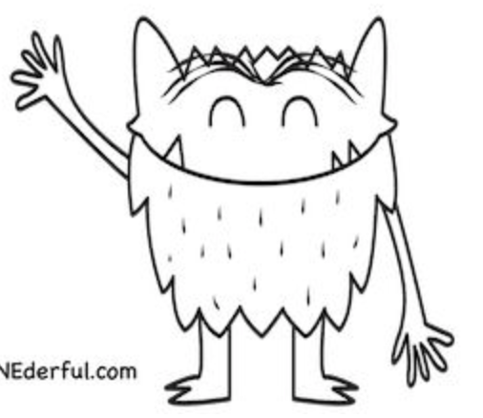

I feel _________________________________.

Colour these jars the correct colour!

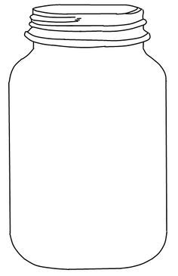

sad
calm
happy

love
fear
anger

Phase 4 High Frequency and Tricky Word Mat
went | just | like | some
from | help | one | come
children | said | have | there
little | were | do | what
it’s | out | when | so

Phase 3 High Frequency and Tricky Word Mat
will | with | my | we
that | for | see | you
then | he | too | her
now | them | was | be
she | down | all | they
this | me | look | are

Phase 3 sounds

Phase 4 Polysyllabic Words
helpdesk | sandpit
windmill | pondweed
desktop | helper
handstand | shampoo
lunchbox | chimpanzee
thundering | zigzag

