Good morning, all, and welcome to the new-look daily home learning sheet.

Daily home learning sheet

From now on, I will make suggestions regarding Oak National Academy and BBC Bitesize work at the start of the week. These suggestions will direct you to a week’s worth of work.

Hopefully by now you are familiar enough with these two resources to continue to use them if you feel they are worthwhile and are engaging your child.

For those of you whose children are ready for something a little different, I will be suggesting a daily maths and English challenge and a wider curriculum challenge for the whole school each day. There will also be themed days and end-of-week challenges that the pupils can take part in.

The choice is yours and theirs!

Class Dojo
Remember to keep sending work to staff on Class dojo and keeping up to date with the Class Story.

Many thanks for your support at this time.

Katy Kent

A reminder of the ongoing presentation project:
For the KS1 pupils, it would be great if they could create a short video (one or two minutes long) in which they read, show or talk about their work to an imagined audience who might watch the video and learn from it. The pupils can choose anything to present: art work, Lego models, writing, toy collections, pets.

Try to speak clearly and in detail, KS1!

For KS2 pupils, it would be great if they could create a PowerPoint presentation for an imagined audience. The pupils can choose anything as the subject of their presentation. It could of course be about one of their current wider curriculum topics (as listed at the top of previous home learning task sheets), or it could be about any topic of their choosing: football, martial arts, nail art, High School Musical, pets, chocolate – anything!

When finished, the pupils could be encouraged to share the presentation with another family member, reading it themselves in a clear, confident and engaging voice.

Whole School Wider Curriculum Challenge
Today’s focus: Design and Technology

The Cardboard Chair Challenge

The James Dyson Foundation has some wonderful challenges on its website: https://www.jamesdysonfoundation.co.uk/resources/challenge-cards.html

You can download a PDF full of different ideas.

The challenge is to make a chair out of nothing but cardboard that is strong enough to support your weight – or even your parent’s weight!

Visit the website, scroll down to Challenge 04 and watch the video.

Good luck and send us some photos as evidence on Class Dojo!
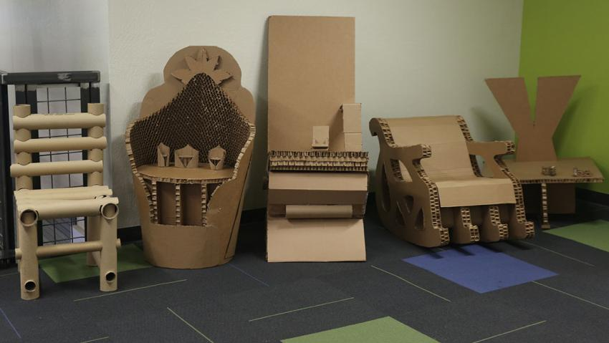
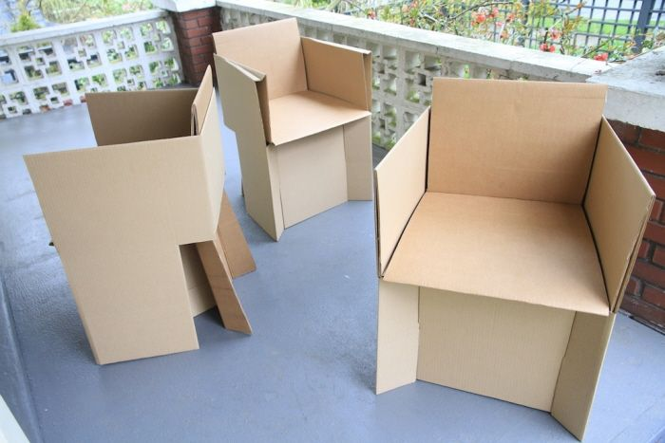

These images may be of some use to you.

Nursery | Please choose activities from last week’s activity sheet (attached)
Reception | Oak National Academy  Maths – Addition and Subtraction  There are 10 lessons in this sequence if you would like to continue using Oak National Academy.  If you click on this link, https://classroom.thenational.academy/subjects-by-year/reception/subjects/maths and scroll down until you reach the 10 lessons with the heading ‘Addition and subtraction’.  Lesson 1 is entitled ‘Combining 2 quantities to find the totals’.  Please then select the next lesson in this way each day.  English – The Crocodile Who Didn’t Like Water by Gemma Murino  There are 5 lessons in this sequence if you would like to continue using Oak National Academy for English.  If you click on this link, https://classroom.thenational.academy/subjects-by-year/reception/subjects/english and scroll a good way down until you reach the 5 lessons with the heading ‘The Crocodile Who Didn't Like Water by Gemma Murino’.  Lesson 1 is entitled ‘To learn some features of reptiles’.  Please then select the next lesson in this way each day.
BBC Bitesize

https://www.bbc.co.uk/bitesize/tags/zjpqqp3/year-1-and-p2-lessons From now on I would recommend completing the Maths and English lessons that are uploaded each day, as your child is about to make the transition to Year 1. The wider curriculum updates (science, history, geography, etc) are also useful and offer a variety of topics that might ignite your child’s interest. The wider curriculum lessons are listed on the Bitesize website as ‘More’.
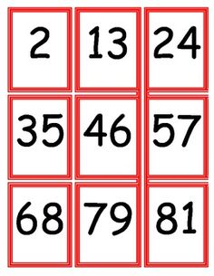
One off Maths lesson

Answer the phone!

Make around 10 to 15 number cards with numbers which are appropriately challenging for your child.

Easier: Pretend to phone your child by ‘typing’ in a number from one of their number cards on your mobile phone. Say the number as you type it in. They have to select the correct number and ‘answer’ that card by picking it up and putting it to their ear. Start a conversation with something like, “Oh, hello, Big Bad Wolf! How are you today?” Challenge your child to adopt a different character each time and have a conversation with them in character: “Did you eat a pig today?” “What was there house made from?” “Did you see Little Red Riding Hood today?”

Harder: The same challenge but instead of saying the number as you dial it, you could say, “I am dialling a number that is bigger than _ but smaller than _.” Or “I am dialling a number that is one more/one less/two more/two less than _”
English

Sky Handwriting!

http://www.ictgames.com/mobilePage/skyWriter/index.html Using this non-Flash activity, you can play a game that will help with your child’s letter formation.

Select a letter while your child closes their eyes or looks away. When the plane starts to fly across the screen, can your child shout out which letter is being formed before it is completed?

Then write down the letter 5 times at the same time as your child and see which one of you has done it the neatest! Feel free to do a ‘bad job’ and see if your child can give you pointers as to how to improve!

The ‘night sky’ mode might make it easier for some children to see the letters, and the ‘cursive’ mode gets the pupils ready to join their letters. This is not necessary yet, however.

Year 1 | Oak National Academy  Maths – Multiplication and Division  There are 10 lessons in this sequence if you would like to continue using Oak National Academy.  If you click on this link, https://classroom.thenational.academy/subjects-by-year/year-1/subjects/maths and scroll down until you reach the 10 lessons with the heading ‘Multiplication and division’.  Lesson 1 is entitled ‘To find double and half of an amount of money’.  Please then select the next lesson in this way each day.  English – Information Text  There are 5 more related lessons to the sequence completed last week.  If you click on this link, https://classroom.thenational.academy/subjects-by-year/year-1/subjects/english and scroll down until you reach the 10 lessons with the heading ‘Information Text’. The next lesson in the sequence is Lesson 6 (‘To listen to an information text’).  Please then select the next lesson in this way each day.
BBC Bitesize

https://www.bbc.co.uk/bitesize/tags/zjpqqp3/year-1-and-p2-lessons From now on I would recommend completing the Maths and English lessons that are uploaded each day. You might want to challenge your child by exploring the Year 2 options below. The wider curriculum updates (science, history, geography, etc) are also useful and offer a variety of topics that might ignite your child’s interest. The wider curriculum lessons are listed on the Bitesize website as ‘More’.
Maths
Sort it out!

Write these numbers on pieces of paper or card (you can change the numbers to make them more appropriate for your child):

2 25 32 7 14 25 38 100 50 11 1 8

In how many different ways can you sort them out or order them?

You could order them from smallest to largest, or largest to smallest.
You could sort them into groups of odd and even.
Can you sort them into times tables groups?
One-digit, two-digit and thee-digit?
Can you order them in any other ways?

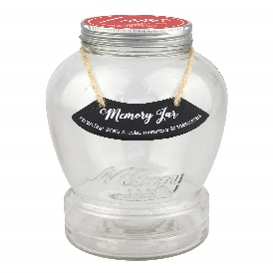
English
The Magical Memory Jar

Your teacher has started to pack her suitcase full of Year 1 memories for this year.

She needs your help!

She wants to pack 5 memories in the suitcase that will always remind her of this year. What should she pack?

Write out the five memories in your best handwriting.

Here are a few ideas:

- My first memory is when we…
- I remember when…
- A funny memory was…

Year 2 | Maths – Exploring Calculation Strategies  There are 10 lessons in this sequence if you would like to continue using Oak National Academy.  If you click on this link, https://classroom.thenational.academy/subjects-by-year/year-2/subjects/maths and scroll down until you reach the 10 lessons with the heading ‘Exploring calculation strategies’.  Lesson 1 is entitled ‘To apply addition strategies to solve equations’.  Please then select the next lesson in this way each day.  English – lesson 1 of 5  https://classroom.thenational.academy/lessons/the-firework-makers-daughter-to-find-the-meaning-of-words-161e95 In this lesson, we are going to be finding the meaning of words from Chapter Two of The Firework Maker’s Daughter. We will be reading pages 25-30.  Parents, I know that The Firework Maker’s Daughter is a rather challenging text for some Year 2 pupils, so feel free to try the Year 1 tasks for this week or I will give alternative BBC Bitesize tasks each day:  https://www.bbc.co.uk/bitesize/articles/zjwcsk7 To be able to identify words that have been contracted (made shorter) and use contracted words in your writing.  If you wish to continue to use Oak National Academy for English but your child is not engaging with the Firework Maker’s Daughter lessons, then I would suggest a change to a non-fiction topic. There is a 5 lesson topic to be found here: https://classroom.thenational.academy/subjects-by-year/year-2/subjects/english. If you scroll a good way down to a sequence of 5 lessons entitled ‘Non-Fiction and non-chronological texts’. The first lesson in the sequence is ‘To retrieve information from a non-chronological text’.  Please then select the next lesson in this way each day.
BBC Bitesize

https://www.bbc.co.uk/bitesize/tags/z7s22sg/year-2-and-p3-lessons From now on I would recommend completing the Maths and English lessons that are uploaded each day. You might want to challenge your child by exploring the Year 3 options below. The wider curriculum updates (science, history, geography, etc) are also useful and offer a variety of topics that might ignite your child’s interest. The wider curriculum lessons are listed on the Bitesize website as ‘More’.

Maths

Guess who’s coming to dinner!

Four Roald Dahl characters are coming to dinner! They are Willy Wonka, Sophie, Matilda, James and Mrs Twit.

They will be sitting at a table like this:

It is your job to sit the characters carefully following these rules:

- Willy Wonka sits opposite Sophie,
- Matilda sits between James and Sophie,
- Mrs Twit sits beside Willy Wonka,
- James sits opposite Sophie.

Write the names on piece of paper and see if you can sort them! Good luck!

English
The Magical Memory Jar

Your teacher has started to pack her suitcase full of Year 2 memories for this year.
She needs your help!
She wants to pack 5 memories in the suitcase that will always remind her of this year. What should she pack?
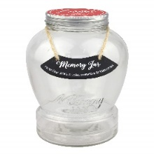
Write out the five memories in your best handwriting.

Here are a few ideas:

- My first memory is when we…
- I remember when…
- A funny memory was…

Year 3 | Maths – Measures  Last Friday’s lesson was as an introduction to a new topic. You can complete the next 5 lessons on capacity and volume this week if you wish:  https://classroom.thenational.academy/subjects-by-year/year-3/subjects/maths  Scroll a good way down to the ‘Measures’ (not the separate ‘Measure’ topic) sequence of 10 lessons. The next lesson is lesson 6 (‘Compare capacity and volume’.)  Please then select the next lesson in this way each day.  English – Newspaper Report  There are 5 lessons in this sequence if you would like to continue using Oak National Academy for English.  If you click on this link, https://classroom.thenational.academy/subjects-by-year/year-3/subjects/english and scroll a good way down until you reach the 5 lessons with the heading ‘Genre focus: Newspaper report’.  Lesson 1 is entitled ‘Reading Comprehension’.  Please then select the next lesson in this way each day.
BBC Bitesize

https://www.bbc.co.uk/bitesize/tags/zmyxxyc/year-3-and-p4-lessons From now on I would recommend completing the Maths and English lessons that are uploaded each day. You might want to challenge your child by exploring the Year 4 options below. The wider curriculum updates (science, history, geography, etc) are also useful and offer a variety of topics that might ignite your child’s interest. The wider curriculum lessons are listed on the Bitesize website as ‘More’.

Maths Challenge

What is the Mystery Number?

Can you work out the mystery number?

- It is an even number,
- It is less than half of one hundred,
- Its two digits added together equal 10.
- It cannot be evenly divided by 3,4,5,6,7,8 or 9.

Move this shape to reveal the answer: 46

English

The 100 Word Challenge!
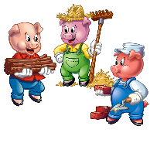
It might help if you use Microsoft Word for this so you can use the word count feature (in the bottom left corner of the screen).
Choose your favourite book or film story. You have only 100 words in which to retell that story.

Rules:
- You must not use the same sentence opener more than once,
- Contractions (such as don’t, can’t, won’t) count as one word,
- You must punctuate the writing correctly,
- You must use at least one question mark and one exclamation mark.

Here’s an effort from one of the teachers in the MAT:
The three little pigs built a house each made from straw, wood and bricks. A nasty big, bad wolf began to eat the pigs one at a time after blowing down their houses, but he could not blow down the brick house. Bravely, the third little pig who lived there tricked the wolf to climb into his house through the chimney! Can you believe it? The wolf fell down the chimney, straight into a pot of boiling water that was cooking on the fire. The wolf jumped straight back up the chimney, ran away, and was never ever seen again.

100 words! He did it!

Year 4 | Maths – Area and Perimeter  If you wish to complete the final 5 lessons in this sequence which started last week, then click this link: https://classroom.thenational.academy/subjects-by-year/year-4/subjects/maths  Find the ten lessons on ‘Area and Perimeter’, and lesson 6 in the sequence will be ‘Area Part 1 – Estimating’ for today.  Please find the next lesson in the sequence in this way each day.  English – Adventure Story  There are 5 lessons in this sequence if you would like to continue using Oak National Academy for English. If you click on this link, https://classroom.thenational.academy/subjects-by-year/year-4/subjects/english and scroll halfway down until you reach the 5 lessons with the heading ‘Genre focus: Adventure story.’ Lesson 1 is entitled ‘Read example text. Reading Comprehension’.  Please then select the next lesson in this way each day.
BBC Bitesize

https://www.bbc.co.uk/bitesize/tags/z63tt39/year-4-and-p5-lessons From now on I would recommend completing the Maths and English lessons that are uploaded each day. You might want to challenge your child by exploring the Year 5 options below. The wider curriculum updates (science, history, geography, etc) are also useful and offer a variety of topics that might ignite your child’s interest. The wider curriculum lessons are listed on the Bitesize website as ‘More’.

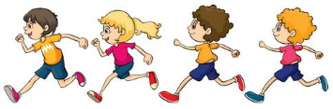
Maths Challenge

Cross Country Race

At a local primary school 300 students were meant to run in the annual cross country competition. However, half of them didn’t run! 80 students had notes excusing them because they felt ill. The rest of the non-runners decided to walk. Out of the students who actually ran, which was half of the whole group, one in five students sprinted, and the rest jogged.

How many of the students missed, walked, jogged and sprinted the cross country race?

English
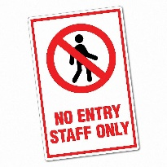
Staff Hub rules!

At the moment, the school hall has been turned into a ‘Staff Hub’ with chairs at least 2 metres apart, so your teachers can still meet and work together while keeping a safe distance.

I wondered if you could write five rules for the staff to follow.

If you handwrite them, you could take a photo and send it to me or your teacher n Class Dojo.
Remember to use imperative verbs (bossy comand verbs) -tidy, sit, stand, keep, clean, etc and adverbs (carefully, slowly, safely, steadily) to make the instructions clear. Be polite, though!

You can turn your rules into a poster. I promise we will stick them up in the hall and take photos to prove it to you!

You can make the rules as silly as you like!

Here are some examples:

- Carefully wash your grubby hands so that you do not spread germs.
- Eat quietly so that no other staff members can hear you.
- Remember to laugh uproarously at Mrs Kent jokes even though they might not be that funny..

Year 5 | Maths – Transformations  There are 10 lessons in this sequence if you would like to continue using Oak National Academy.  If you click on this link, https://classroom.thenational.academy/subjects-by-year/year-5/subjects/maths and scroll a good way down until you reach the 10 lessons with the heading ‘Transformations’.  Lesson 1 is entitled ‘An Introduction to Translation’.  Please then select the next lesson in this way each day.  English – Newspaper Reports  There are 5 lessons in this sequence if you would like to continue using Oak National Academy for English.  If you click on this link, https://classroom.thenational.academy/subjects-by-year/year-5/subjects/english and scroll down to the bottom until you reach the 5 lessons with the heading ‘Newspaper report’.  Lesson 1 is entitled ‘Reading comprehension’.  Please then select the next lesson in this way each day.
BBC Bitesize

https://www.bbc.co.uk/bitesize/tags/zhgppg8/year-5-and-p6-lessons From now on I would recommend completing the Maths and English lessons that are uploaded each day. You might want to challenge your child by exploring the Year 6 options below. The wider curriculum updates (science, history, geography, etc) are also useful and offer a variety of topics that might ignite your child’s interest. The wider curriculum lessons are listed on the Bitesize website as ‘More’.

Maths Challenge
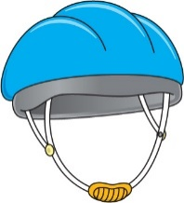
Mrs Shuttleworth’s Bike Store!

Mrs Shuttleworth’s bicycle store only sells helmets for £60 and lycra bike shorts for £35. One Saturday morning Mrs shuttleworth sold ten items for a total of £425.

What combination of helmets and bike shorts must Mrs Shuttleworth have sold?

You will have to solve this using ‘trial and error’. Try as many different combinations of helmets and bike shorts as you can and add the total each time.

Remember, only 10 items were sold altogether!

Move this shape to reveal the answer: 3 helmets and 7 pairs of shorts.

English

Write about your funniest memory from Year 5.
Did someone miss their chair as they sat down? Did you call Mrs Shuttleworth or Mrs Dudgon ‘Mum’ during the year?

There is a twist to this challenge, though.
Every sentence must start with the SAME LETTER that finished the sentence before:

I remember laughing wildly when David kicked the football and his shoe flew off. Forever will I remember that hilarious sight. Totally out of the blue, he swung his foot and …

It’s a fun way to make you think about variying your sentence openers.

Year 6 | Maths – Fractions  There are five more lessons in the sequence which follow on from Friday’s lesson if you wish to continue them this week.  Click on this link: https://classroom.thenational.academy/subjects-by-year/year-6/subjects/maths  Then scroll down and you will see the 15 lessons with the heading ‘Fractions’. The next lesson in the sequence is Lesson 11 (Fractions: to represent multiplication with proper fractions).  Please find the next lesson each day in this way.  English – Newspaper Reports  There are 5 lessons in this sequence if you would like to continue using Oak National Academy for English.  If you click on this link, https://classroom.thenational.academy/subjects-by-year/year-6/subjects/english and scroll down over halfway until you reach the 5 lessons with the heading ‘Genre focus: Explanation’.  Lesson 1 is entitled ‘Reading focus: Summary’.  Please then select the next lesson in this way each day.  There are also Year 7 lessons which might be appropriate for your child as they prepare for the transition to secondary school:  English: https://classroom.thenational.academy/subjects-by-year/year-7/subjects/english  Maths: https://classroom.thenational.academy/subjects-by-year/year-7/subjects/maths
BBC Bitesize

https://www.bbc.co.uk/bitesize/tags/zncsscw/year-6-and-p7-lessons From now on I would recommend completing the Maths and English lessons that are uploaded each day. You might want to challenge your child by exploring the Year 7 or even Year 8 options below. The wider curriculum updates (science, history, geography, etc) are also useful and offer a variety of topics that might ignite your child’s interest. The wider curriculum lessons are listed on the Bitesize website as ‘More’.
Year 7 Bitesize: https://www.bbc.co.uk/bitesize/tags/zf9yy9q/year-7-and-s1-lessons
Year 8 Bitesize: https://www.bbc.co.uk/bitesize/tags/zvdbbdm/year-8-and-s2-lessons

Maths Challenge

Mrs Shuttleworth, on her summer holiday, flew an aircraft from Bristol to Edinburgh in 2 hours, covering exactly 375 miles. The next day she drove back to Bristol taking 8 hours.

What was her average speed for the whole trip? Move the shape to see the solution.
75 miles per hour. I added together the two distances (750miles) and the time it took altogether (10 hours). I then divided the distance by the time to get an average hourly speed.

English

What are your memories of all your time at All Saints’ – could you write them into a rhyming couplet poem?

If you could give one piece of advice to a child joining us in Reception at All Saints’ – what would it be?

NRich Maths Challenges!

Years 1 and 2 - https://nrich.maths.org/5157 Sort the houses in different ways. This should encourage good maths talk and reasoning.
Years 3 and 4 - https://nrich.maths.org/7725 This activity will make your children think carefully about how best to represent data.
Years 5 and 6 - https://nrich.maths.org/7522 This challenge explores data represented in different ways.

Other websites and games to explore:

https://www.topmarks.co.uk/ - I have used this website for some of the warm-up games today. There is an easy-to-use search engine that suggests games, activities and programs for all subjects and ages.

https://www.topmarks.co.uk/maths-games/hit-the-button - From the Topmarks website, this is a popular way of practising times tables, addition and subtraction, number bonds and doubling and halving.

https://www.bbc.co.uk/bitesize/collections/primary-games/1 – There are some games here we have used already, but they are well worth exploring a little more, as some of them are useful for learning about the wider curriculum. The subject the game relates to is listed below the game’s image.

https://home.oxfordowl.co.uk/ I used some of these resources as maths warm up games last week. There is a lot on here in terms of games, activities and resources. There is also a useful reading level check for younger children with direct links to Amazon ( https://home.oxfordowl.co.uk/reading/reading-schemes-oxford-levels/which-reading-level-stage/ ) if you wish to purchase reading books for over the summer holidays. Of course, you can contact your child’s teacher for this information as well. We would love to send reading books home to the home learners but there is an embargo on this at the moment as it is against government guidelines to do so. We sincerely apologise for this.

https://whiterosemaths.com/resources/schemes-of-learning/primary-sols/ This website is a little tricky to navigate but there are some great free downloadable resources available when you select the appropriate year’s schemes of work lower down this first page. We closely follow this scheme at school.

https://authorfy.com/masterclasses/ (Ages 5-11) For those of you looking for different reading and writing challenges, this website contains many resources created by best-selling authors. You will have to register, but there is no fee. There are author-led videos and schemes of work included. If your child already owns one of the books listed, then this is perfect for work related to that book. Free extracts of ALL books are provided, though, with work related to that extract. There are writing competitions on the website as well.

https://schoolreadinglist.co.uk/competitions-for-children/childrens-writing-competitions/ There is a comprehensive list here of competitions that your children might wish to enter.

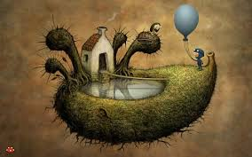
https://amanita-design.net/questionaut/ Questionaut is an absolutely wonderful, charming, challenging and memorable KS2 game, which poses questions about English, Maths and Science. The level designs are wonderful, and the pupils have to solve a puzzle to unlock the questions from that level. Years 5 and 6 can play this independently, whereas Years 3 and 4 might need a little assistance (and a calculator for the trickier maths sums!). I hope you love it!
The game appears small on the screen, so zoom in on the web page to about 150%.

Project Ideas for the Wider Curriculum (more ideas to follow):

Years 1 and 2:
Science – Plants
- plant seeds in a pot or garden (sunflower) and keep a picture or photo diary of how they grow;
- plant a bulb in a jar and observe root growth;
- see how many of each type of plant you can spot on a walk near your home.

Geography – On the Beach
- make sea water at home.
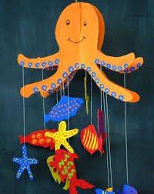
Add 35 grams of salt to a beaker, and then add tap water until the total mass is 1,000 grams, stirring until the salt is completely dissolved in the water. Tap water often contains lots of natural minerals found in seawater, such as magnesium and calcium.
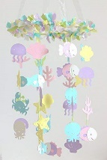
What does it taste like? Does it look or smell any different from fresh water? Do things float or sink differently in it? Can you use stones or rocks from your garden to make a rock pool?
- NEW! A sea creature mobile would look awesome. Investigate what creatures you might find on a beach in the UK!

Years 3 and 4:
Science – Plants
- see if you like any of the Years 1 and 2 projects;
- plant seeds (pumpkin seeds are good, as they grow quickly) in four separate containers at the same time and expose them to different conditions:
- Do not water this plant;
- Place this plant in a dark place, water it;
- Place this plant in a sunny but cold place, water it;
- Place this plant in a sunny, warm place, water it.
How do the different conditions affect the plant’s growth?

Geography – What a disaster! (natural disasters)
- Follow these instructions (https://www.learning4kids.net/2012/04/11/how-to-make-a-homemade-volcano/ ) to make a working model of a volcano;
- Create an instructional poster explaining what to do in the event of an earthquake. There are some good tips here: https://www.youtube.com/watch?v=d08QUmxzdKU

Years 5 and 6:
Science – Electricity
- Create an inventory (item list) for your house. How many switches are there? How many bulbs? How many plug sockets? How many electrical appliances? How many appliances that require batteries? How many of these are switched ‘on’ at the time of your inventory? Check at different times during the day. At what time are most ‘on’? At what time are the fewest number ‘on’?
- Use the ‘energy calculator’ on this website to calculate how much money some of your appliances are costing you: https://www.sust-it.net/energy-calculator.php. Can you create a plan for how to save money for your house? Think about how much you could save per week, or per year.

Geography –Climate Zones (and time zones)
- https://www.timeanddate.com/time/map/#!cities=179 – Use this time zone map to help you create a world time snapshot (on paper or using Microsoft Word or Powerpoint) showing what different people in different countries might be doing when you sit down to lunch in the UK at 12:00pm.
- Select one (or all) of the climate zones (biomes) and create a guide to where in the world they are, what conditions are found there and what life is there.
Remember, the main zones are: rainforests, deserts, savannah, woodlands, grasslands, tundra .
Watch this again to help you: https://www.bbc.co.uk/bitesize/topics/z849q6f/articles/zvsp92p

