Dear Parents and Carers,

Here is an overview of tasks I would like children to complete at home over the next week. We are committed to making sure that your child is still learning as much as possible and endeavour to do our best to keep this happening. I would be grateful if you could email me 2 pieces of their work/ activities per day. This could just be a simple photograph of them completing a task. If there is anything that they or you need, please do not hesitate to contact me via email: sbroad@allsaints-trysull.staffs.sch.uk or on Class Dojo. Thank you for your support.

Warmest regards, Miss Broad.

Summer Term 2
Week 6 – Growing and Changing
This week we are exploring ‘old’ and ‘new’ and thinking about our transition into a new year group in September.

Text of the week:
The Dinosaur that Pooped the Past by Dougie Poynter and Tom Fletcher

Nursery Challenges for Specific Areas of Learning

 | Maths | Phonics
Monday | Challenge 1 | Watch Geraldine learn about the ‘d’ sound. Play Buried Treasure using ‘d’ words to practise your blending!
Tuesday | Challenge 2 | Watch Geraldine learn about the ‘g’ sound. Play picnic on Pluto using ‘g’ words to practise blending to read.
Wednesday | Challenge 3 | Watch Geraldine learn about the ‘o’ sound.  Play this game to read ‘o’ in words.
Thursday | Challenge 4 | Watch Geraldine learn about the ‘c’ sound.  Read the ‘c’ caption in additional resources and match to the correct picture.
Friday | Challenge 5 | Watch Geraldine learn about the ‘k’ sound.  Read the ‘k’ caption in additional resources and match to the correct picture.

Reception tasks for Specific Areas of Learning

 | Maths | Phonics
Monday | Challenge 1 | Learn to read ‘ou’ cloud by playing this game.
Tuesday | Challenge 2 | Learn to read ‘oy’ boy by working hard on this worksheet!
Wednesday | Challenge 3 | Learn the ‘ir’ girl grapheme by completing this workbook.
Thursday | Challenge 4 | Learn to read new grapheme ‘aw’ by finding ‘aw’ words in this wordsearch.
Friday | Challenge 5 | Learn to read tricky words ‘could’ ‘should’ and ‘would’ by training your brain!

In addition to this, choose 1 of these literacy activities a day (both Nursery and Reception):

- Read our story of the week (The Dinosaur that Pooped the Past). What does the past mean?
- Stop halfway through the story and predict what might happen in the rest of the story based on what you have read so far.
- Sequence the story using the additional resources sequencing document.
- Read the letter from the A B C dinosaurs from our story of the week (additional resources). Can you underline all of the question marks? What kinds of words do the questions begin with? Can you write your own questions?
- Write a letter back to the A B C dinosaurs answering their questions and asking some of your own!

Tasks for Prime Areas of Learning. Please complete 1 of any of these a day.
Year Group: EYFS (Nursery and Reception)

PSED/Communication and Language
- As we are looking at old and new this week, this lends itself well to discussing transition. The transition sheet in the additional resources (things I liked doing in this class, things I am looking forward to doing in my new class) may help to guide the discussion and get children excited for returning.
- Nursery: Miss Floyd has asked me to send you something so she can get to know you! Please can you fill in the ‘All About Me’ sheet in the additional resources and send it back to me on Class Dojo? I can then show Miss Floyd how fabulous you all are!

Physical Development
- Complete one of these a day:
* Boogie Beebies with Oti Mbuse on Cbeebies iPlayer
* Go Noodle workouts on Youtube
*Cosmic Kids Yoga workouts on Youtube
*PE with Joe Wicks on Youtube at 9am every week day
*Disney 10 minute shake up activities
- Handwriting practise – please focus on correct letter formation. Handwriting worksheets are available on Twinkl.
- Nursery specific: pencil control sheets (Twinkl) to help with fine motor development and holding a pencil with the correct grip.

Understanding the World
- Look at photos of you as a baby. How have you changed from then to now? What can you do now that you didn’t used to be able to do?
- Look at photos of other family members when they were younger – how have they changed? What toys did they play with that are different to the kinds of toys you have? Did they have iPads?

Expressive Arts and Design
- I have created each pupil a login for ‘Yumu’ on the Charanga website which is the package we use to teach music. I have assigned them a package of work if they would like to do some music! If you would like your login and details on how to access the work, please email me.
- Nick Rowland is an artist who creates vibrant paintings of volcanoes using paint splattering. Have a look at his work in Additional Resources and see if you can recreate your own volcano, using bright colours to show the eruption just like we saw in The Dinosaur that Pooped the Past!
Useful Links:
This is a fantastic free resource to really motivate children to practise their reading skills.
https://www.teachyourmonstertoread.com/

Blue Peter are running a ‘Six Badges of Summer’ campaign that children (EYFS and their older siblings too!) may want to take part in.
https://www.bbc.co.uk/cbbc/joinin/six-badges-of-summer

Additional Resources

Phase 5a High Frequency and Tricky Word Mat
Mr | Mrs | called | looked
could | don’t | old | about
made | asked | I’m | house
your | very | by | time
came | make | their | day
saw | put | oh | people
here

Phase 4 High Frequency and Tricky Word Mat
went | just | like | some
from | help | one | come
children | said | have | there
little | were | do | what
it’s | out | when | so

Phase 3 High Frequency and Tricky Word Mat
will | with | my | we
that | for | see | you
then | he | too | her
now | them | was | be
she | down | all | they
this | me | look | are

Phase 2 High Frequency and Tricky Word Mat
a | dad | I | mum
big | it | at | is
on | up | back | if
but | of | into | his
to | him | had | in
no | got | the | go
an | as | can | off
not | get | and

Phase 3 sounds

Phase 5 Sounds

All about ______________________________

I am _________ years old.

This is my family…

My favourite toys to play with are…

When I grow up I want to be…

Things I don’t like are…

Things I like are…

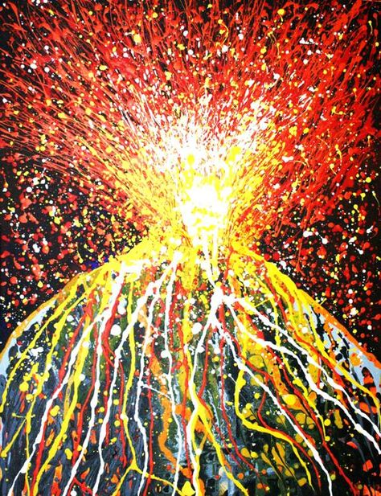
Nick Rowland ‘Volcano’ Artwork

Letter from Dinos A B and C

Dear Superstar Home Learner,

Our names are Dino A, B and C and we are writing you a letter to find out more about you. What is your name? How old are you? Where do you go to school? Who is your best friend?

Miss Broad says you have been looking at our book this week. Did you enjoy it? What was your favourite part? In the story, Granny makes our friend Danny eat lots of green things – yuck! What is your favourite food?

We would love to hear back from you. Can you write us a letter answering our question and asking us some questions too?

From,
Dinos A B and C x

Sequencing Activity

Setting

Characters

Beginning

Middle

End

Transition Sheet

Questions I would like to ask Miss Broad/Miss Floyd:

Things I am looking forward to in my new class:

Things I like about my class:

